**SCD Lab 07**

**Name:** Hafsa Salman

**Roll no.** 22K-5161

**index.jsp**

Code:

<html>  
<body>  
<h2>22K-5161: SCD Lab 07</h2>  
<a href = "Home.jsp">Task no. 01</a> <br>  
<a href = "Task_02.jsp">Task no. 02</a> <br>  
<a href = "Task_03.jsp">Task no. 03</a> <br>  
<a href = "Factorial.jsp">Task no. 04</a> <br>  
<a href = "Order.jsp">Task no. 05</a> <br>  
<a href = "Input.jsp">Task no. 06</a>  
</body>  
</html>

Output:

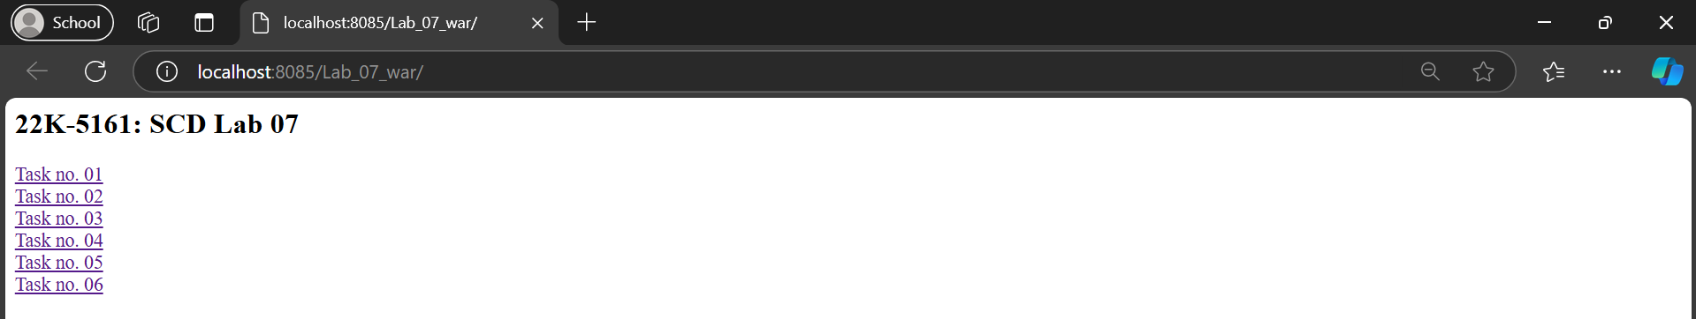

**Task 01**

Code:

//Home.jsp

<!--  
Hafsa Salman  
22K-5161  
Task no. 01  
-->  
  
<%@ **include** file="/common/header.jsp" %>  
  
<h1 class="mt-5">Welcome to 22K-5161: Task no. 01</h1>  
<p>This is the homepage of the JSP website styled with Bootstrap.</p>  
  
<%@ **include** file="/common/footer.jsp" %>

//header.jsp

<!--  
Hafsa Salman  
22K-5161  
Task no. 01  
-->  
  
<!DOCTYPE html>  
<html lang="en">  
<head>  
 <meta charset="UTF-8">  
 <meta name="viewport" content="width=device-width, initial-scale=1.0">  
 <title>22K-5161 (Task no. 01)</title>  
 <link href="https://maxcdn.bootstrapcdn.com/bootstrap/4.5.2/css/bootstrap.min.css" rel="stylesheet">  
</head>  
<body>  
<nav class="navbar navbar-expand-lg navbar-light bg-light">  
 <a class="navbar-brand" href="home.jsp">22K-5161</a>  
 <button class="navbar-toggler" type="button" data-toggle="collapse" data-target="#navbarNav" aria-controls="navbarNav" aria-expanded="false" aria-label="Toggle navigation">  
 <span class="navbar-toggler-icon"></span>  
 </button>  
 <div class="collapse navbar-collapse" id="navbarNav">  
 <ul class="navbar-nav">  
 <li class="nav-item"><a class="nav-link" href="Home.jsp">Home</a></li>  
 <li class="nav-item"><a class="nav-link" href="About.jsp">About</a></li>  
 <li class="nav-item"><a class="nav-link" href="Contact.jsp">Contact</a></li>  
 <li class="nav-item"><a class="nav-link" href="Register.jsp">Register</a></li>  
 <li class="nav-item"><a class="nav-link" href="Signin.jsp">SignIn</a></li>  
 </ul>  
 </div>  
</nav>  
<div class="container">

//footer.jsp

<!--  
Hafsa Salman  
22K-5161  
Task no. 01  
-->  
  
</div>  
<footer class="footer mt-5 py-3 bg-light">  
 <div class="container text-center">  
 <span class="text-muted">2024 22K-5161 (Task no. 01) All rights reserved.</span>  
 </div>  
</footer>  
<script src="https://code.jquery.com/jquery-3.5.1.min.js"></script>  
<script src="https://cdn.jsdelivr.net/npm/bootstrap@4.5.2/dist/js/bootstrap.bundle.min.js"></script>  
</body>  
</html>

//About.jsp

<!--  
Hafsa Salman  
22K-5161  
Task no. 01  
-->  
  
<%@ **include** file="/common/header.jsp" %>  
  
<h1 class="mt-5">About Us</h1>  
<p>22K-5161 (Task no. 01)</p>  
  
<%@ **include** file="/common/footer.jsp" %>

//Contact.jsp

<!--  
Hafsa Salman  
22K-5161  
Task no. 01  
-->  
  
<%@ **include** file="/common/header.jsp" %>  
  
<h1 class="mt-5">Contact Us</h1>  
<form>  
 <div class="form-group">  
 <label for="name">Name</label>  
 <input type="text" class="form-control" id="name" placeholder="Enter your name">  
 </div>  
 <div class="form-group">  
 <label for="email">Email</label>  
 <input type="email" class="form-control" id="email" placeholder="Enter your email">  
 </div>  
 <div class="form-group">  
 <label for="message">Message</label>  
 <textarea class="form-control" id="message" rows="3"></textarea>  
 </div>  
 <button type="submit" class="btn btn-primary">Submit</button>  
</form>  
  
<%@ **include** file="/common/footer.jsp" %>

//Register.jsp

<%@ **include** file="/common/header.jsp" %>  
  
<h1 class="mt-5">Register</h1>  
<h1>22K-5161 (Task no. 01)</h1>  
<form action="Register" method="post">  
 <label for="name">Name:</label>  
 <input type="text" id="name" name="name" required><br><br>  
  
 <label for="email">Email:</label>  
 <input type="email" id="email" name="email" required><br><br>  
  
 <label for="password">Password:</label>  
 <input type="password" id="password" name="password" required><br><br>  
  
 <input type="submit" value="Register">  
</form>  
  
  
<%@ **include** file="/common/footer.jsp" %>

//Signin.jsp

<!--  
Hafsa Salman  
22K-5161  
Task no. 01  
-->  
  
<%@ **include** file="/common/header.jsp" %>  
  
<h1 class="mt-5">Signup</h1>  
<p>Sign In to your account.</p>  
<form action="Signin" method="post">  
 <label for="name">Name:</label>  
 <input type="text" id="name" name="name" required><br><br>  
  
 <label for="email">Email:</label>  
 <input type="email" id="email" name="email" required><br><br>  
  
 <label for="password">Password:</label>  
 <input type="password" id="password" name="password" required><br><br>  
  
 <input type="submit" value="Signin">  
</form>  
  
<%@ **include** file="/common/footer.jsp" %>

//Task_01_Register.java

//Hafsa Salman  
//22K-5161  
//Task no. 01  
  
import jakarta.servlet.annotation.WebServlet;  
import jakarta.servlet.http.HttpServlet;  
import jakarta.servlet.http.HttpServletRequest;  
import jakarta.servlet.http.HttpServletResponse;  
import jakarta.servlet.http.HttpSession;  
  
import java.io.IOException;  
  
@WebServlet(name = "Task_01_Register", urlPatterns = "/Register")  
public class Task_01_Register extends HttpServlet  
{  
 @Override  
 protected void doPost(HttpServletRequest req, HttpServletResponse resp) throws IOException  
 {  
 String name = req.getParameter("name");  
 String email = req.getParameter("email");  
 String password = req.getParameter("password");  
  
 HttpSession session = req.getSession();  
 session.setAttribute("registeredName", name);  
 session.setAttribute("registeredEmail", email);  
 session.setAttribute("registeredPassword", password);  
  
 resp.sendRedirect("Signin.jsp");  
 }  
}

//Task_01_Signin.java

//Hafsa Salman  
//22K-5161  
//Task no. 01  
  
import jakarta.servlet.RequestDispatcher;  
import jakarta.servlet.ServletException;  
import jakarta.servlet.annotation.WebServlet;  
import jakarta.servlet.http.HttpServlet;  
import jakarta.servlet.http.HttpServletRequest;  
import jakarta.servlet.http.HttpServletResponse;  
import jakarta.servlet.http.HttpSession;  
  
import java.io.IOException;  
  
  
@WebServlet(name="Task_01_Signin", urlPatterns = "/Signin")  
public class Task_01_Signin extends HttpServlet  
{  
 @Override  
 protected void doPost(HttpServletRequest req, HttpServletResponse resp) throws ServletException, IOException  
 {  
 String email = req.getParameter("email");  
 String password = req.getParameter("password");  
  
 HttpSession session = req.getSession();  
 String registeredEmail = (String) session.getAttribute("registeredEmail");  
 String registeredPassword = (String) session.getAttribute("registeredPassword");  
  
 if (registeredEmail != null && registeredEmail.equals(email) && registeredPassword.equals(password))  
 {  
 session.setAttribute("user", registeredEmail);  
 resp.sendRedirect("welcome.jsp");  
 }  
  
 else  
 {  
 req.setAttribute("error", "Invalid email or password.");  
 RequestDispatcher dispatcher = req.getRequestDispatcher("signin.jsp");  
 dispatcher.forward(req, resp);  
 }  
 }  
}

Output:

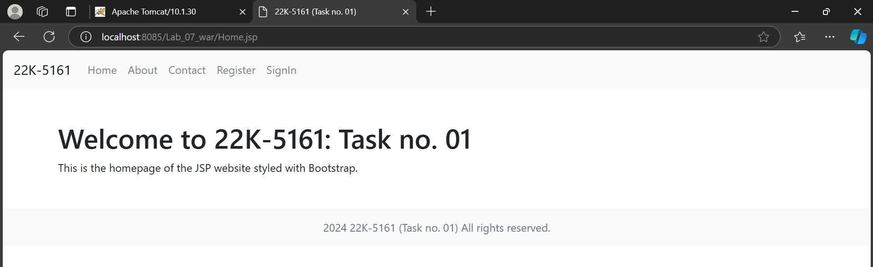

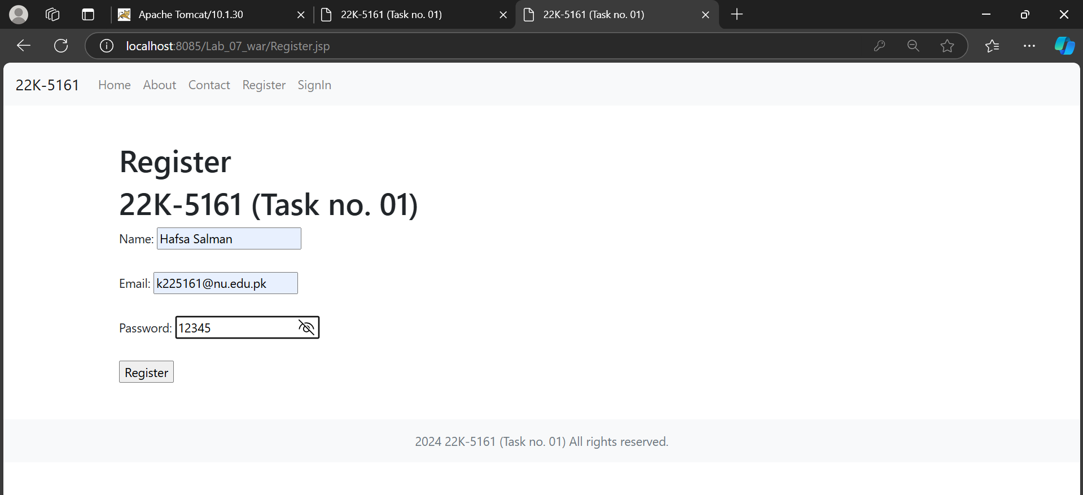

**Task 02**

Code:

Task_02.jsp

<!--  
Hafsa Salman  
22K-5161  
Task no. 02  
-->  
  
<!DOCTYPE html>  
<html lang="en">  
<head>  
 <meta charset="UTF-8">  
 <meta name="viewport" content="width=device-width, initial-scale=1.0">  
 <title>22K-5161 (Task no. 02)</title>  
</head>  
<body>  
<div class="container">  
 <h2>22K-5161: Task no. 02</h2>  
 <form action="Task_02.jsp" method="post">  
 <div class="form-group">  
 <label for="name">Employee Name:</label>  
 <input type="text" id="name" name="name" required>  
 </div>  
  
 <div class="form-group">  
 <label for="basicSalary">Basic Salary:</label>  
 <input type="number" id="basicSalary" name="basicSalary" required min="0" step="0.01">  
 </div>  
  
 <div class="form-group">  
 <label for="allowances">Allowances:</label>  
 <input type="number" id="allowances" name="allowances" required min="0" step="0.01">  
 </div>  
  
 <div class="form-group">  
 <label for="deductions">Deductions:</label>  
 <input type="number" id="deductions" name="deductions" required min="0" step="0.01">  
 </div>  
  
 <button type="submit">Calculate Net Salary</button>  
 </form>  
  
 <%  
 String name = request.getParameter("name");  
 String basicSalaryStr = request.getParameter("basicSalary");  
 String allowancesStr = request.getParameter("allowances");  
 String deductionsStr = request.getParameter("deductions");  
  
 if (name != null && basicSalaryStr != null && allowancesStr != null && deductionsStr != null)  
 {  
 try  
 {  
 double basicSalary = Double.*parseDouble*(basicSalaryStr);  
 double allowances = Double.*parseDouble*(allowancesStr);  
 double deductions = Double.*parseDouble*(deductionsStr);  
 double netSalary = basicSalary + allowances - deductions;  
 %>  
  
 <div class="result">  
 <p>Employee Name: <strong><%= name %></strong></p>  
 <p>Net Salary: <strong>Rs.<%= String.*format*(" %.2f", netSalary) %></strong></p>  
 </div>  
  
 <%  
 }  
  
 catch (NumberFormatException e)  
 {  
 out.println("<p style='color: red;'>Error in processing the numbers.</p>");  
 }  
 }  
 %>  
  
</div>  
</body>  
</html>

Output:

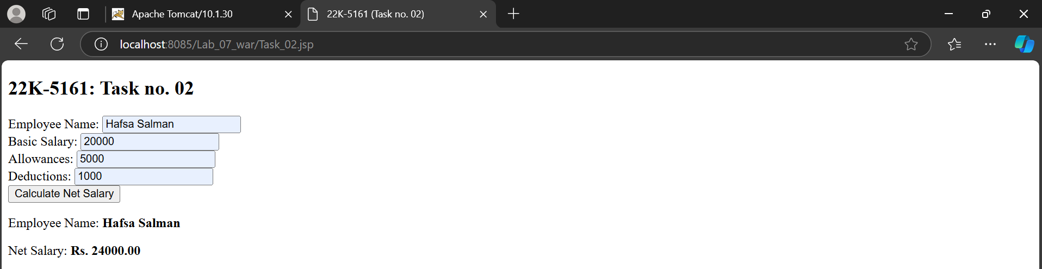

**Task 03**

Code:

//Task_03.jsp

<!--  
Hafsa Salman  
22K-5161  
Task no. 03  
-->  
  
<!DOCTYPE html>  
<html lang="en">  
<head>  
 <meta charset="UTF-8">  
 <meta name="viewport" content="width=device-width, initial-scale=1.0">  
 <title>22K-5161 (Task no. 03)</title>  
</head>  
<body>  
<h2>22K-5161 (Task no. 03)</h2>  
<form action="Task_03.jsp" method="post">  
 <label for="firstName">First Name:</label>  
 <input type="text" id="firstName" name="firstName" required><br><br>  
  
 <label for="lastName">Last Name:</label>  
 <input type="text" id="lastName" name="lastName" required><br><br>  
  
 <label for="age">Age:</label>  
 <input type="number" id="age" name="age" required min="0"><br><br>  
  
 <button type="submit">Submit</button>  
</form>  
  
<%  
 String firstName = request.getParameter("firstName");  
 String lastName = request.getParameter("lastName");  
 String ageStr = request.getParameter("age");  
  
 if (firstName != null && lastName != null && ageStr != null)  
 {  
 try  
 {  
 int age = Integer.*parseInt*(ageStr);  
 String fullName = firstName + " " + lastName;  
 String message = (age >= 18) ? "You are an Adult" : "You are a Minor";  
%>  
  
<h3>22K-5161: Task no. 03</h3>  
<p>Full Name: <strong><%= fullName %></strong></p>  
<p><%= message %></p>  
<%  
 }  
  
 catch (NumberFormatException e)  
 {  
 out.println("<p style='color: red;'>Invalid age format. Please enter a number.</p>");  
 }  
 }  
%>  
</body>  
</html>

Output:

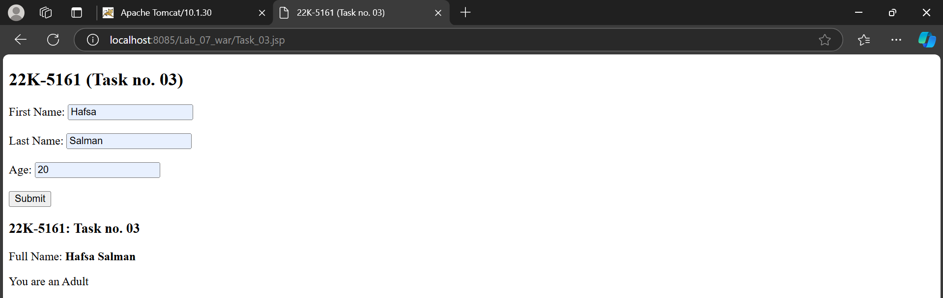

**Task 04**

Code:

//Factorial.jsp

<!--  
Hafsa Salman  
22K-5161  
Task no. 04  
-->  
  
  
<!DOCTYPE html>  
<html lang="en">  
<head>  
 <meta charset="UTF-8">  
 <meta name="viewport" content="width=device-width, initial-scale=1.0">  
 <title>22K-5161 (Task no. 04)</title>  
</head>  
<body>  
<h2>22K-5161: Task no. 04</h2>  
<form action="Factorial.jsp" method="post">  
 <label for="number">Enter a number:</label>  
 <input type="number" id="number" name="number" required min="0"><br><br>  
 <button type="submit">Calculate Factorial</button>  
</form>  
  
<%!  
 public int calculateFactorial(int n)  
 {  
 int result = 1;  
  
 for (int i = 1; i <= n; i++)  
 {  
 result *= i;  
 }  
  
 return result;  
 }  
%>  
  
<%  
 String numberStr = request.getParameter("number");  
  
 if (numberStr != null)  
 {  
 try  
 {  
 int number = Integer.*parseInt*(numberStr);  
 int factorial = calculateFactorial(number);  
%>  
  
<h3>22K-5161: Task no. 04</h3>  
<p>The factorial of <strong><%= number %></strong> is <strong><%= factorial %></strong>.</p>  
<%  
 } catch (NumberFormatException e)  
 {  
 out.println("<p style='color: red;'>Invalid input. Please enter a valid number.</p>");  
 }  
 }  
%>  
</body>  
</html>

Output:

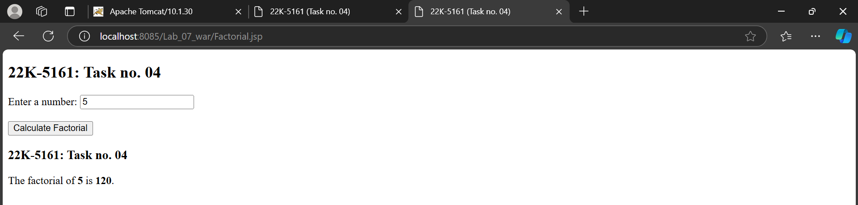

**Task 05**

Code:

//Order.jsp

<!--  
Hafsa Salman  
22K-5161  
Task no. 05  
-->  
  
<!DOCTYPE html>  
<html lang="en">  
<head>  
 <meta charset="UTF-8">  
 <meta name="viewport" content="width=device-width, initial-scale=1.0">  
 <title>22K-5161 (Task no. 05)</title>  
</head>  
<body>  
<h2>22K-5161: Task no. 05</h2>  
<form action="Confirmation.jsp" method="post">  
 <label for="email">Email Address:</label>  
 <input type="email" id="email" name="email" required><br><br>  
  
 <label for="product">Product Name:</label>  
 <input type="text" id="product" name="product" required><br><br>  
  
 <label for="quantity">Quantity:</label>  
 <input type="number" id="quantity" name="quantity" required min="1"><br><br>  
  
 <button type="submit">Submit Order</button>  
</form>  
</body>  
</html>

//Confirmation.jsp

<!--  
Hafsa Salman  
22K-5161  
Task no. 05  
-->  
  
<%@ **page** contentType="text/html;charset=UTF-8" language="java" %>  
<!DOCTYPE html>  
<html lang="en">  
<head>  
 <meta charset="UTF-8">  
 <meta name="viewport" content="width=device-width, initial-scale=1.0">  
 <title>22K-5161 (Task no. 05)</title>  
</head>  
<body>  
<%  
 String email = request.getParameter("email");  
 String product = request.getParameter("product");  
 String quantity = request.getParameter("quantity");  
%>  
  
<h2>22K-5161: Task no. 05</h2>  
<p>Thank you, <strong><%= email %></strong>, for your order!</p>  
<p>Order Details:</p>  
<ul>  
 <li>Product: <strong><%= product %></strong></li>  
 <li>Quantity: <strong><%= quantity %></strong></li>  
</ul>  
<p>Your order has been received and is being processed.</p>  
</body>  
</html>

Output:

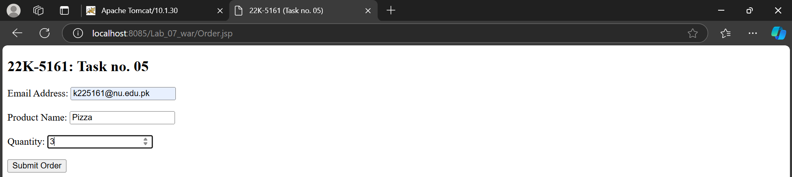

**Task 06**

Code:

//Input.jsp

<!--  
Hafsa Salman  
22K-5161  
Task no. 06  
-->  
  
<!DOCTYPE html>  
<html lang="en">  
<head>  
 <meta charset="UTF-8">  
 <meta name="viewport" content="width=device-width, initial-scale=1.0">  
 <title>22K-5161 (Task no. 06)</title>  
</head>  
<body>  
<h2>22K-5161: Task no. 06</h2>  
<form action="Input.jsp" method="post">  
 <label for="firstName">First Name:</label>  
 <input type="text" id="firstName" name="firstName" required><br><br>  
  
 <label for="lastName">Last Name:</label>  
 <input type="text" id="lastName" name="lastName" required><br><br>  
  
 <button type="submit">Submit</button>  
</form>  
  
<%  
  
 String firstName = request.getParameter("firstName");  
 String lastName = request.getParameter("lastName");  
  
 if (firstName != null && lastName != null) {  
%>

<**jsp:forward** page="Greeting.jsp">  
 <**jsp:param** name="firstName" value="<%= firstName %>" />  
 <**jsp:param** name="lastName" value="<%= lastName %>" />  
</**jsp:forward**>

<%  
 }  
%>  
</body>  
</html>

//Greeting.jsp

<!--  
Hafsa Salman  
22K-5161  
Task no. 06  
-->  
  
<!DOCTYPE html>  
<html lang="en">  
<head>  
 <meta charset="UTF-8">  
 <meta name="viewport" content="width=device-width, initial-scale=1.0">  
 <title>22K-5161 (Task no. 06)</title>  
</head>  
<body>  
<%  
 String firstName = request.getParameter("firstName");  
 String lastName = request.getParameter("lastName");  
%>  
  
<h2>22K-5161: Task no. 06</h2>  
<p>Hello, <strong> <%= firstName %> <%= lastName %> </strong>! Welcome to our website!</p>  
</body>  
</html>

Output:



